TrapRange: a Method to Extract Table Content in PDF Files

**THO Q LUONG @ SETA ASIA**

**HANOI, VIETNAM**

**Introduction**

Table data structure is one of the most important data structures in document, especially when exporting data from systems, data is usually in table format.

Having several data file formats are often used to store data including csv, text, pdf. For first two formats, it is very easy to extract data content by opening files, loop through lines and split cells depending on its cell separator, and of course we already had many libraries that help us to do that work automatically. It's normal work. But with pdf file, it's not a familiar format to read and process directly from InputStream because it is a complicating file format that can contain not only text data, font, content style, but also image, audio and video [1]. In this post, we’re going to describe our solution used to extract table data in pdf files. Our solution was implemented, experimented and adapted with pdf files having high density of table content. The advantages and disadvantages of our solution are also discussed.

**What is a “document having high density of table content”?**

A document having high density of table content is a document that most of it content is contained in a single table. Content that is not in this table is called "noisy content". Our solution focuses on this kind of table because it aims to extract table content in pdf file that contains exported data from systems. Example: your customer exports their users data in a pdf file (lots of systems only support exporting data in this format) and you must import them into your app, of course, these data is in table format. In our algorithm, we set threshold of 20%, if percent of noisy line in every page of a document is less than or equal to the threshold then this document is high density of table content.

**How to recognize a table**

After some investigation i realized that:

1. **Column**: text content in cells of the same column lies on a rectangular space that does not overlap with other rectangular spaces of another column. Example: see the following image, red rectangle and blue rectangle are separated spaces
2. **Row**: words are in same horizontal alignment are in the same row. But this is just enough condition because a cell in a row may be a multi-line cell. For example: the fourth cell in the yellow line has two lines, phrases “FK to this customer’s record in” and "Ledgers table" are not int same horizontal alignment but they are still considered in the same row. In our solution, we simply assume that content in a cell only is single-line content. Different lines in a cell are considered to belong to different rows. So the content in the yellow rectangle contains two rows: 1. {"Ledger_ID", "|" , "Sales Ledger Account" , "FK to this customer's record to"} 2.  {NULL , NULL , NULL , "Ledgers table"}

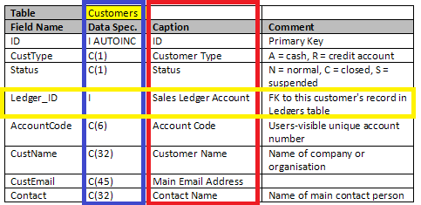

**ICEpdf API [2]**

Our work is based on the data returned by ICEpdf API, an opensource project. To extract text from a pdf file, ICEpdf API provides 4 classes:

* Document: contains information of entire pdf file, in order to load a pdf file we use method Document.setUrl(url: URL)
* PageText: represents for each page in pdf Document, we can archive a specific page content by passing the index of the page with this method: Document.getPageText(pageIdx: int)
* LineText: represents a group of text chunks that are horizontal alignment but text in the same line in document may not return in the same LineText object. Example, ICEpdf may return two or more LineText object although these objects seem to be data of the same line. LineText is make up WordText objects
* WordText: represents an individual word in the document. Archiving all WordText objects of a LineText via method LineText.getWords(). A WordText object has method getBounds() that returns its position in page.

In our work, we process directly with text chunks by using WordText objects. For each text chunk in PDF file it returns a text element with following attributes:

* x: horizontal distance from the left of the page
* y: vertical distance from the top border of the page
* maxX: equals x + width of the text chunk
* maxY: equals y+ height of the text chunk

C:\Users\ThoLuong\AppData\Local\Temp\enhtmlclip\bound-sample.png

**Preprocessing:** classifying text chunks into lines

Our first approach to classify text chunks into lines is based on algorithm DBSCAN (Density-based spatial clustering of applications with noise) [3]. But i found another approach [4] which is simpler and has the same accuracy. The following describes algorithm of the second approach:

Algorithm 1: classifying text chunks into lines

for each WordText w in words of pdf document

begin

     Line line <- lines.getLastLine()

     if line <> NULL && ( w.y or w.maxY lies between line.y and line.maxY) then

          line.y <- min (line.y, w.y)

          line.maxY <- max(line.maxY, w.maxY)

          line.add( w )

     else

          newLine <- new Line()

          newLine.y = w.y

          newLine.maxY = w.maxY

          newLine.add( w )

          lines.add( newLine )

     end if

end

**Trap ranges**

After classifying WordText into lines, now for each line, if this line is a row of data in the table, we need to identify cell for words. So, we got to focus on calculating ranges that contains all WordText of cells corresponding to each table column. We name these ranges are trap-ranges

Trap range has attributes:

* x: vertical distance from the left of page
* maxX: x + width of the range

To calculate attributes of trap-ranges, we loop through each line of the page and project range of each word onto horizontal axis and join with existed ranges. After looping through all lines of page we will calculate trap-ranges and using them to identify cell data of the table. Example:

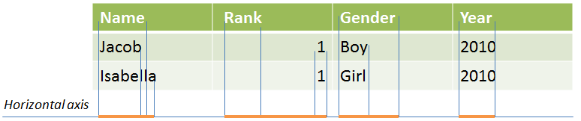

Algorithm 2: calculating trap-ranges for each pdf page:

trapRanges <- []

for each Line line in lines of page

begin

     for each WordText w in words of line

     begin

          trapRanges <- join(trapRanges , {w.x, w.maxX} ), {w.x, w.maxX} )

     end

end

**Avoid noisy data**

Algorithm 2 only works well without noisy line. Noisy lines are lines that don't belong to the table, when join them with trap-ranges, they may connect all trap-ranges to single one then damage our result. Following is an example that noisy line joins with existed trap-ranges:

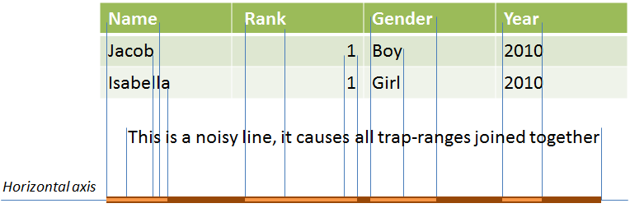

So how to avoid noisy line in our join operation? As mentioned above, we uses threshold of 20% and a blacklist to save lines that may be noisy lines, after looping through all lines of page, we will re-join lines in black list t

o make the trap-ranges more accurately. Following is our algorithm to avoid noisy data when calculating trap-ranges

Algorithm 3: calculating trap-ranges with noise

trapRanges <- []

blackLines <- []

maxNoisyLines <- 20 * page.getNumberOfLines() / 100

for each Line line in lines of page

begin

     newTrapRanges = trapRanges;

     for each WordText w in words of line

     begin

          newTrapRanges <- join(newTrapRanges , {w.x, w.maxX} )

     end

     if newTrapRanges .size() < trapRanges.size() then

          if blackLines.size() < maxNoisyLines then

               blackLines.add(line)

          else

               throw exception: the document is not a "high desity of table content" document

          end if

     else

          trapRanges <- newTrapRanges

     end if

end

// rejoin with lines in blacklist to make trap-ranges more accurate

for each line in blackLines

     newTrapRanges = trapRanges;

     for each WordText w in words of line

     begin

          newTrapRanges <- join(newTrapRanges, {w.x, w.maxX})

     end

     if newTrapRanges.size == trapRanges.size then

          trapRanges <-newTrapRanges

     end if

end

After calculating TrapRanges for the table, we loop through text chunks in each line again and classify text chunks into correct cells of the table.

Algorithm 4: classifing text chunks into correct cells:

table 🡨 new Table()

for each line in lines of document

     line 🡨 new Line()

     for each word in line

          rangeIdx 🡨 in trapRanges, get index of the range that contains current word

          if range >= 0 then

               line.saveWord(word, rangeIdx)

          else

               break //noisy line

          end if

     end

     if line is not empty then

          table.saveRow(line)

     end if

end

**Design and implement**

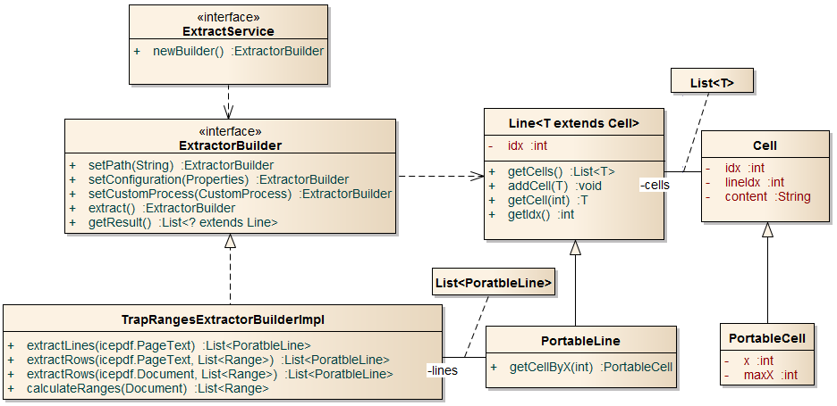

The above is class diagram that describes main classes in our projects:

* **ExtractService** is an interface having method newBuilder() to create an implementation of ExtractorBuilder
* **Line**/**Cell**: in situation of a page, it contains a line/words in the pdf document; in situation of a table it contains a row/cell in table
* **ExtractorBuilder** is the most important interface, it contains methods to initialize and extract table data from an input pdf file. Builder pattern was applied for this interface. Methods in this interface:
  + setPath: set filePath of pdf file
  + setConfiguration: set custom configurations for the builder
  + setCustomProcess: CustomProcess allows you to verify extracted table data
  + extract: do extraction
  + getResult: get result of the builder after extraction process. This method return list of rows of table
* **TrapRangesExtractorBuilderImpl**: this is a builder implementation using TrapRanges method. The class contains main methods:
  + calculateRanges: calculate trap-ranges using algorithm 3
  + extractLines: using algorithm 1 to classify text chunks into lines
  + extractRows: extract table data from a pdf page or pdf document

To extract table data from a pdf file, we use following code block:

ExtractService pdfExtractService = ExtractorServiceFactory.getExtractService("pdf");// may have other implementations for other document format, for example: csv, word...

List<Line> result = pdfExtractService.newBuilder()

                                   .setPath("seta-table.pdf")

                                   .setCustomProcess(null)

                                   .extract()

                                   .getResult();

// do some business with the result

**Evaluation**

In experimentation, we use pdf files having high density of table data. The results show that our implementation realizes table data better than other opensource tools: pdftotext [5], pdftohtml [5], pdf2table. With documents having multi tables or too much noisy data our method does not work or work incorrectly. When a table row has a cell overlaps the space of beside columns, this row will be discarded.

**Conclusion**

TrapRange method works best with pdf files having high density of table data. With documents have multi-tables or too much noisy data TrapRange is not a good choice. Our method also can be implemented in other programming language by replacing ICEpdf by a corresponding pdf library or using command-line tool pdftohtml[5] to extract text chunks and their attributes in pdf file and using these data as input data for algorithm 1, 4.

**Reference:**

1. <http://en.wikipedia.org/wiki/Portable_Document_Format>

2. <http://res.icesoft.org/docs/icepdf/latest/core/>

3. <http://en.wikipedia.org/wiki/DBSCAN>

4. <http://ieg.ifs.tuwien.ac.at/pub/yildiz_iicai_2005.pdf>

5. <http://www.foolabs.com/xpdf/>

6. <http://ieg.ifs.tuwien.ac.at/projects/pdf2table/>